**Practical no 9: write down sql by using WHERE CLAUSE GROUP BY HAVING CLAUSE**

**NAME :- Rushikesh Divakar Borale ROLL NO -23**

**DIV :- A BATCH –B1**

select*from employee;

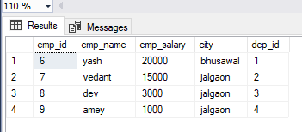

1. WHERE CLAUSE :

select emp_name,emp_salary from employee where emp_salary !=5000 group by emp_name,emp_salary;

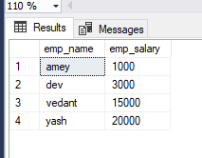

1. GROUP BY:

select emp_name,emp_salary,count(*) from employee group by emp_name,emp_salary;

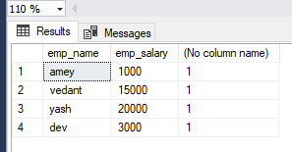

1. HAVING CLAUSE:

select emp_name,emp_salary from employee group by emp_name,emp_salary having (emp_salary)>11000;

